Esri User Conference In-Person Registration
Go to the Esri User Conference Registration page and click Register for in-person event.

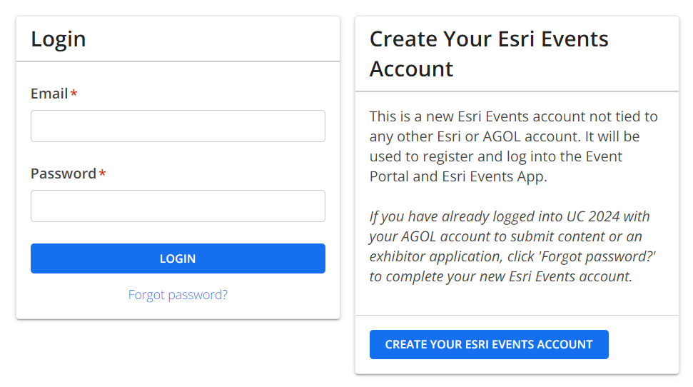

- Click on CREATE YOUR ESRI EVENTS ACCOUNT
- Fill out your name and email and set up a password. WRITE DOWN YOUR PASSWORD
- Click on ‘I am registering myself’, then click ‘Continue’

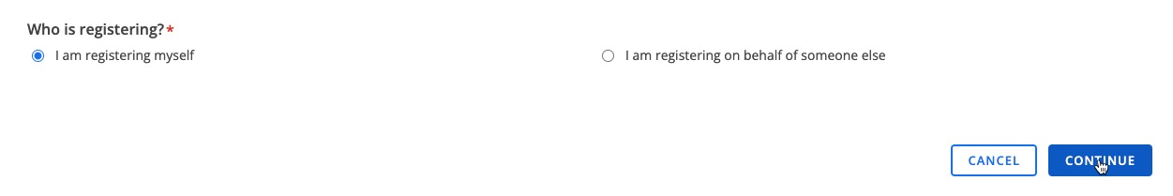

- Fill out your name, Redlands.edu email, address, etc. Use University of Redlands as the Organization. Click ‘Continue’.
- Using the drop down, choose ‘I want to enter in my customer number’.
- Use 12498 as our customer number.

- Click ‘Submit’
- Fill in your emergency contact information.
- For Organization type, choose Education.
- For Industry, choose Higher Education
- Choose ‘Student’ as your Functional Role
- Agree to the Communication Acknowledgment and Attendee Acknowledgement
- Select User Conference for ‘Which event are you interested in attending?’

- Click ‘Continue’.

- On the next page, choose the following option.
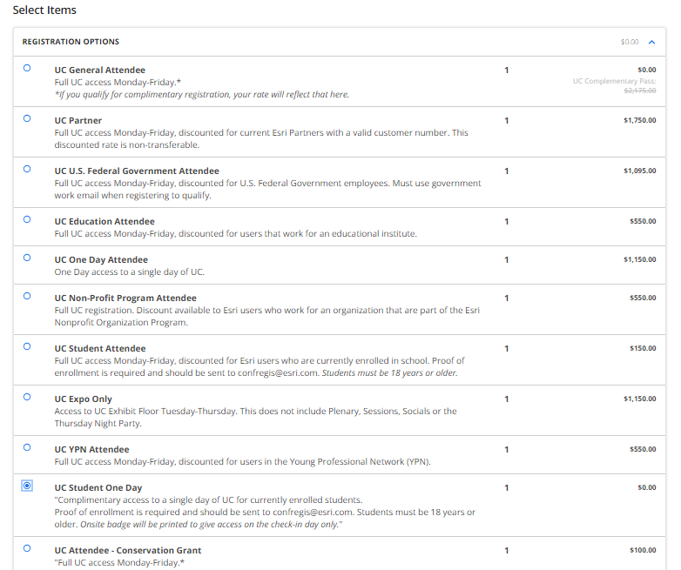

NOTE: Anyone who has registered for the in-person event will automatically receive digital access once it becomes available.

- At the bottom of the page, click Submit Order.
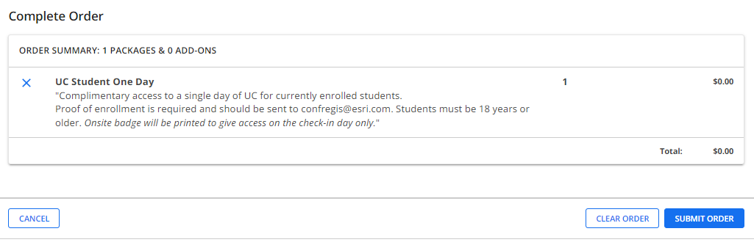
“Complimentary access to a single day of UC for currently enrolled students.
Proof of enrollment is required and should be sent to confregis@esri.com. Students must be 18 years or older. “

Within a few minutes, you should get a confirmation email from Esri. You can now checkout the adgenda and create your schedule.

If you encounter any difficulty registering, contact spatialstudies@redlands.edu.

See you at the show!

