Loma Linda Behavioral Health Institute
Low-Fee and Sliding Scale Counseling Services
For more information visit: Llubhi.org

For appointments: Call (909) 558-9500, option 2

Location: 1686 Barton Rd. Redlands, CA 93373 (3-4 miles from the University)
Rates:
Supervised Intern: Sliding scale starts at $10/appointment (might change after income verification).
Licensed therapist: Sliding scale starts at $160/appointment (might change after income verification).

Directions: From Interstate 10, take exit 77A to Alabama Street in Redlands California. If you are coming from the East, take the exit and turn left on Alabama Street. If you are coming from the West, take the exit and turn right on Alabama Street.
- Continue 1.3 miles on Alabama Street.
- Turn right on Barton Road and continue 0.2 miles.
- Turn into the Behavioral Health Institute parking lot on the right.

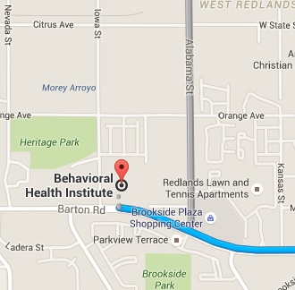
Map & Transportation Options:
University of Redlands Off-campus Shuttle

2pm – 10pm (last pick-up 9:30pm) Sunday & Monday
3pm – 10pm (last pick-up 9:30pm) Tuesday-Friday
3pm – 11pm (last pick-up 10:30pm) Saturday

To contact the driver directly, dial (909) 856-0476
*Advanced reservations not permitted, but must call at least 30 minutes prior to pick-up time to check driver schedule.
-Bus- Omnitrans Route #19 will take you from the UoR to the LLU Behavioral Health Institute. $1.75/ way. You may pick up the westbound bus at Citrus Ave. & University St, and disembark at Barton Rd. & Terracina Blvd. Bus passes, and exact change for payment. For additional information visit Omnitrans.org. Departs approximately 23 and 53 minutes past the hour.

Taxi
Xpress Yellow Cab: (909) 532-9871 Appx. $16/ one way
Redlands Taxi (909) 798-1111
A1-Yellow Cab (909) 884-1111

Zip Car
Reservations start at $8.50/ hour (180 miles included per day; $.45 per mile after that). Join for $15 annually. (Must be a licensed driver for at least a year.) Check their website for current membership offers/incentives.
For more information visit www.zipcar.com/redlands

Uber
Download the Uber app and sign up for services at www.uber.com.
One Way Trip to LLBHI $8.80
PICK UP
Base Fare $0.00
Long Pickup Fee Variable
Per Minute to Pickup $0.15
Per Mile to Pickup $1.01

CANCELLATIONS
Cancellation Fee Variable
Standard Driver Initiated Cancellation Fee $5.00
Standard Rider Initiated Cancellation Fee $5.00
Per Minute Prior to Cancellation $0.15
Per Mile Prior to Cancellation $1.01

Lyft
Download the Lyft app and sign up for services at www.lyft.com
One Way Trip to LLBHI $8-10 (12 minutes)
Base Fare | $0.00
Cancel Penalty | $5.00
Cost Per Mile | $1.01
Cost Per Minute | $0.15
Maximum Fare | $400.00
Minimum Fare | $4.00
Scheduled Ride Cancel Penalty | $10.00
Scheduled Ride Minimum Fare | $4.00
Service Fee | $3.30

