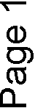
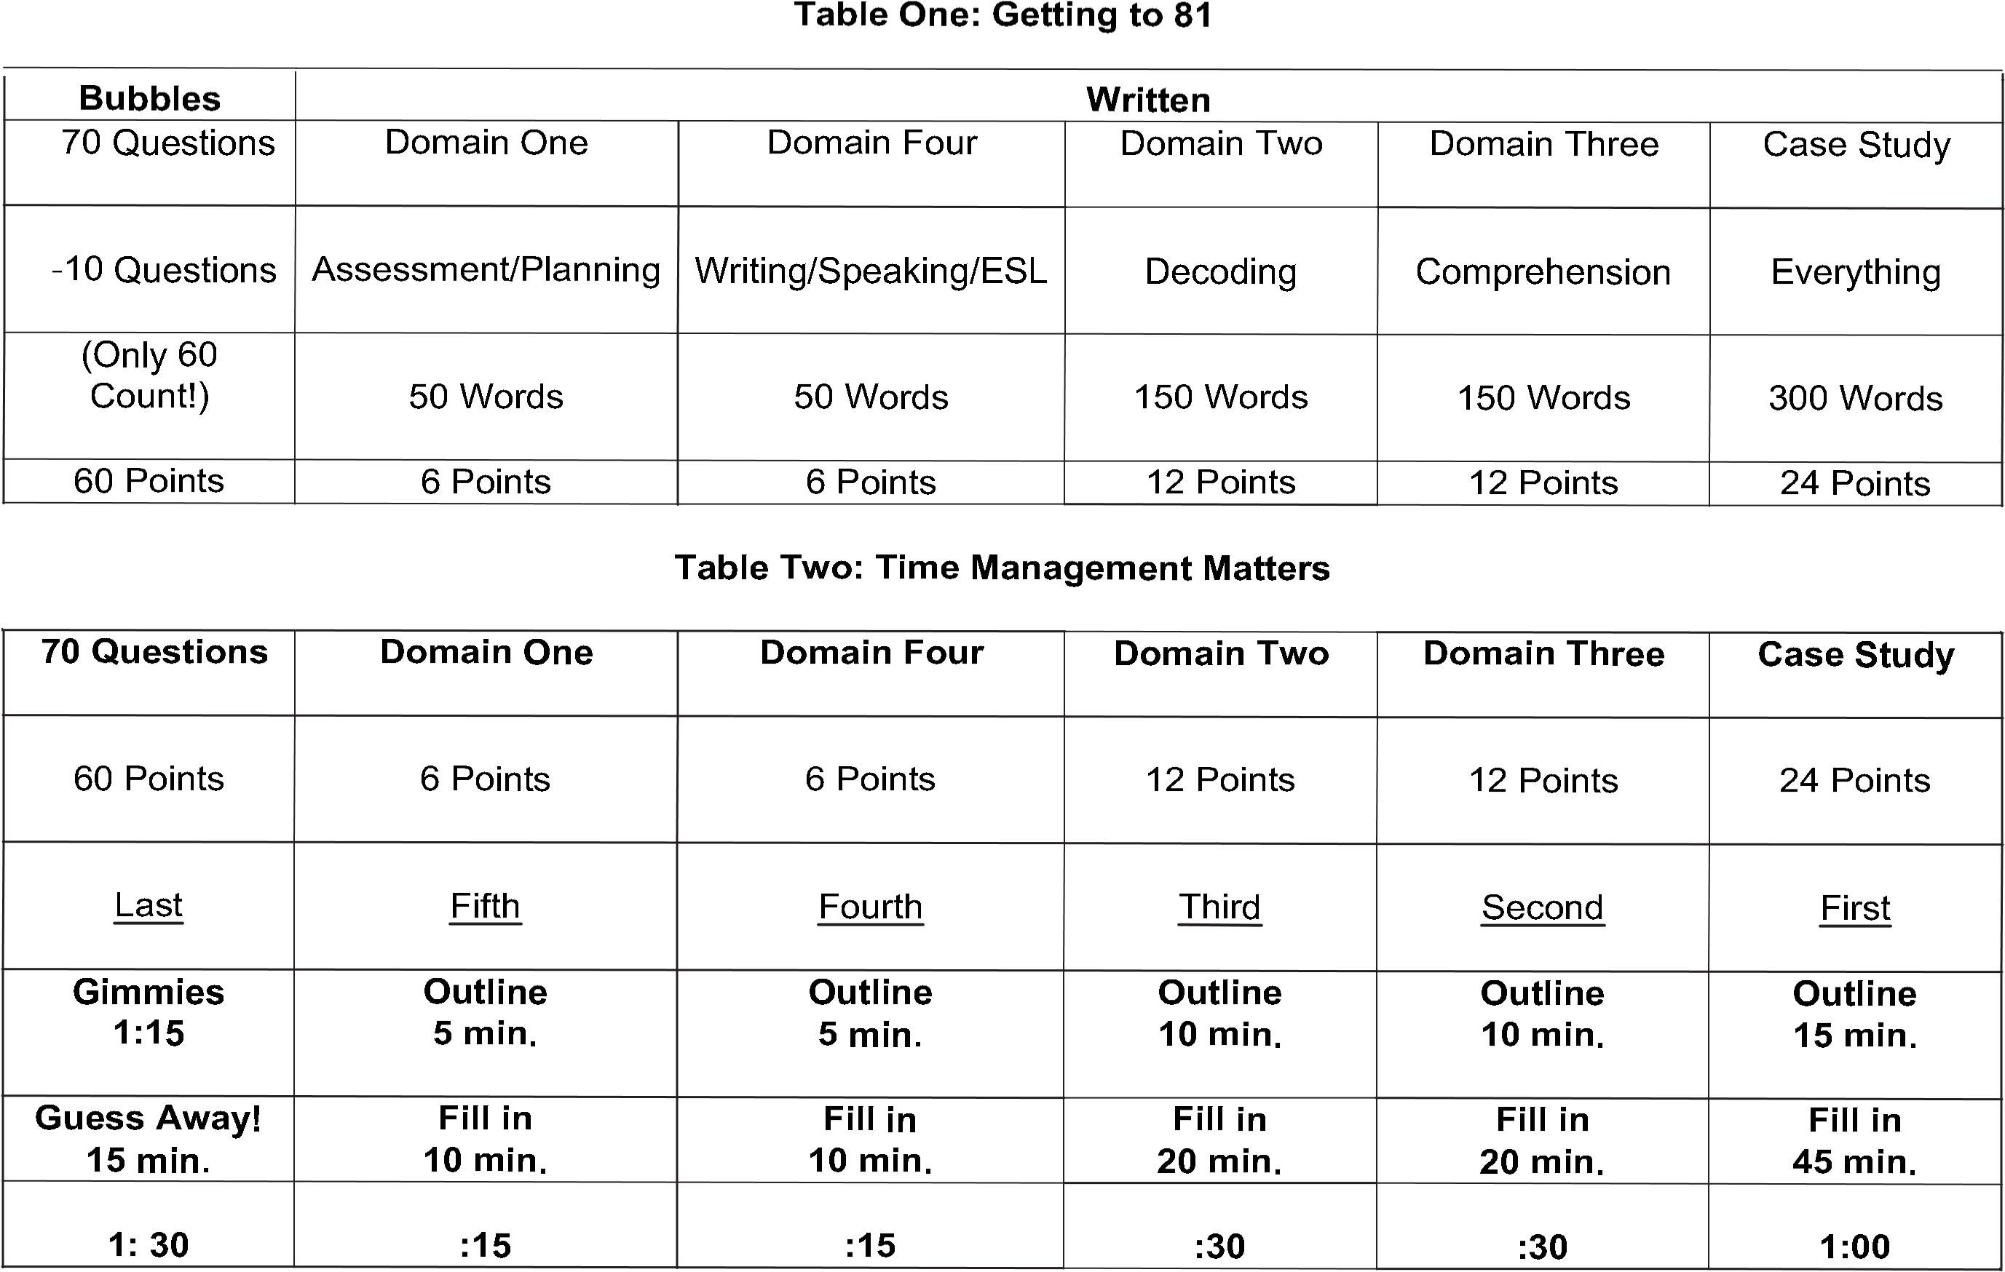
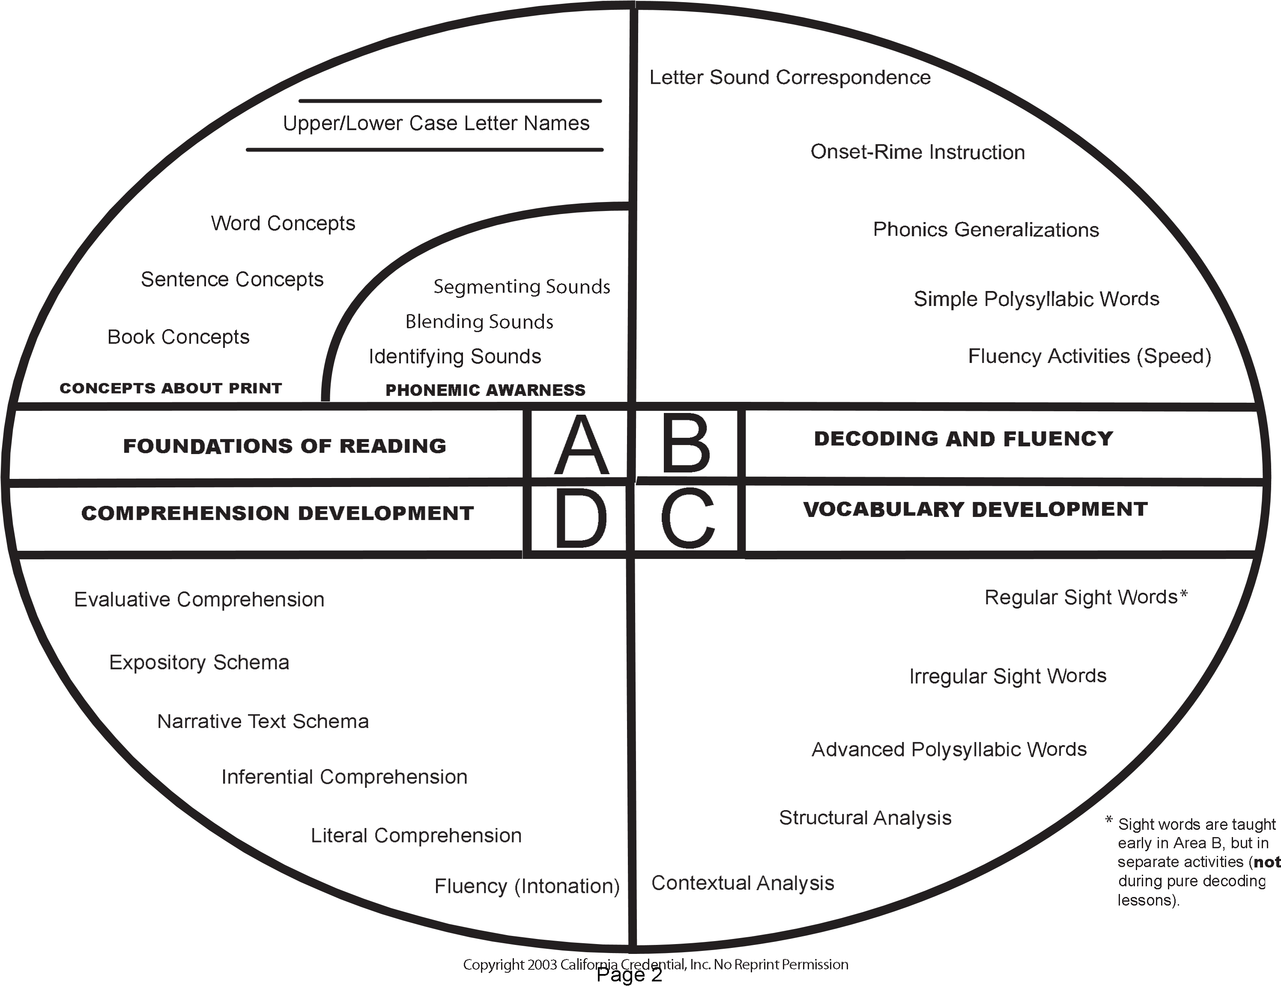

Learning­to­Read

A. Foundations of Reading (Kindergarten)
Concepts about Print and Phonemic Awareness are the foundations They are taught separately but concurrently
Concepts About Print
(order) book, sentence, word, and letter concepts letter concepts are the highest
p, b, d, q are typically learned last
Big Book Readings and Morning Messages are common activities
Phonemic Awareness
(order) identifying sounds, blending sounds, segmenting sounds
Identifying |  | Blending |  | Segmenting
/kat/ | /k/ | /k/ /a/ /t/ | /kat/ | /kat/ | /k/ /a/ /t/
Elkonin Boxes and Multi­Sensory Techniques are common activities
Exiting Kindergarten
Both Concepts about Print and Phonemic Awareness must be in place
Letter­naming and segmenting are the exit criteria
1

B. Decoding and Fluency (First – Third Grade)
Begins with letter­Sound correspondence (first grade)
Ends with fluency (third grade)
Letter­Sound Correspondence (First Grade)
Begins with the Alphabetic Principle
Aa | Bb | Cc
Ape | Bee | City
Moves beyond the Alphabetic Principle
Aa | Bb | Cc
Apple | Bat | Cat
Illustrates why the foundations are so critical to learning to read
2
Learning­to­Read
Onset­Rime Instruction (First Grade)
Word Families, Blends, and Digraphs
­AT | “BLENDS” | “DIGRAPHS”
CAT  MAT  HAT  RAT  SAT | BLOCK  TRUCK  STOP  STREET  DROP | SHOCK  PHAT  THAT  WHAT
3
Phonics Generalizations (Second Grade)
Short Vowels |  | Long Vowels |  | Diphthongs
CVC |  | CVCe |  | Vowel Blends
MAT  PET  BIT  NOT  CUT |  | MATE  PETE  BITE  NOTE  CUTE |  | BOY  TOIL  COW
CCVC ­ CCVCC |  | VV – DIGRAPHS |  | R­CONTROL
DROP­ BLOCK |  | EACH, PAINT *BREAD, HEAD |  | CAR, BIRD, FUR
HARD/SOFT C |  | HARD/SOFT G |  | SHORT VOWEL II
CAT COT | CITY CYCLE | GAME GOT | GYM RAGE | DROP ­ DROPPING
4
Simple Polysyllabic Words (Third Grade)
Open Syllabes | Closed Syllables | Examples
mama | Batman | Repeat  extreme
 | El e phant
Fluency (Third Grade)
- Speed: Child must decode quickly to have enough short term memory available to comprehend what he/she reads
- Intonation: Child must read expressively (?,!) to comprehend text and dialogue in stories.
5

C. Vocabulary Instruction (First – Third Grade)
Begins with Sight Words (First Grade) and ends with Context (Eighth Grade)
Regular and Irregular Sight Words (First – Third Grade)
Regular Sight Words |  |  | Irregular Sight Words
The, was, saw, there, some |  |  | Through, thorough, throughout
 | Decoding (9AM) | Sight Words (10 AM) |  | Fluency (11AM)
 | CAT  MAT  SAT  RAT | THE ON  BY  NEAR |  | The cat sat on the mat.  The cat sat near the mat.
6
Advanced Polysyllabic Words (Fourth Grade)
Inflectional Suffixes plurals, possessives  comparatives, superlatives  verb tenses |  |  | Derivational Affixes  Prefixes and Suffixes  “Structural Analysis” | Roots Free and Bound
Cats Mike’s | Taller Tallest | Runs  Walked  Walking | Denationalization De nation al iz ation | Chris  Wednesday | Aster  Asteroid  Asterisk
7
Contextual Analysis
Homophones | Homographs | Multiple Meaning Words
Cite, site, sight  To, too, two  Their, there, they’re | Lead (v) Lead (n)  Subject (v) Subject (n)  Minute (adj.) Minute (n) | Cool  Denotation – Dictionary  Below body temperature  Connotation – Slang  She’s a cool teacher.
8
Reading­to­Learn

D. Comprehension (Fourth through Eighth Grade)
Fluency (Third Grade)
Remember: Fluency (speed and intonation) is the gateway to comprehension
Literal Comprehension (Fourth Grade)
Factual Understanding
Who, What, Where, and When
Without literal comprehension, there can be no Inferential Comprehension
Inferential Comprehension (Fourth Grade)
Contextual Understanding
How and Why Questions
Reading between the lines, using context, and making predictions
Narrative Text Schema (Fifth Grade)
Narrative schema means organization of stories, novels, and poems
Plot, Setting, Character (protagonist/antagonist), symbol, metaphor
Story Maps are common instructional techniques
Expository Text Schema (Fifth Grade)
Expository chema means organization of science, social studies, and math books
Main idea/Supporting idea; compare/contrast; problem/solution structures
Venn diagrams, outlines, and webs are common instructional techniques
Evaluative Comprehension (Eight Grade)
This is the highest level in the model
It means distinguishing fact from opinion and detecting propaganda
9
CHRIS CASE STUDY
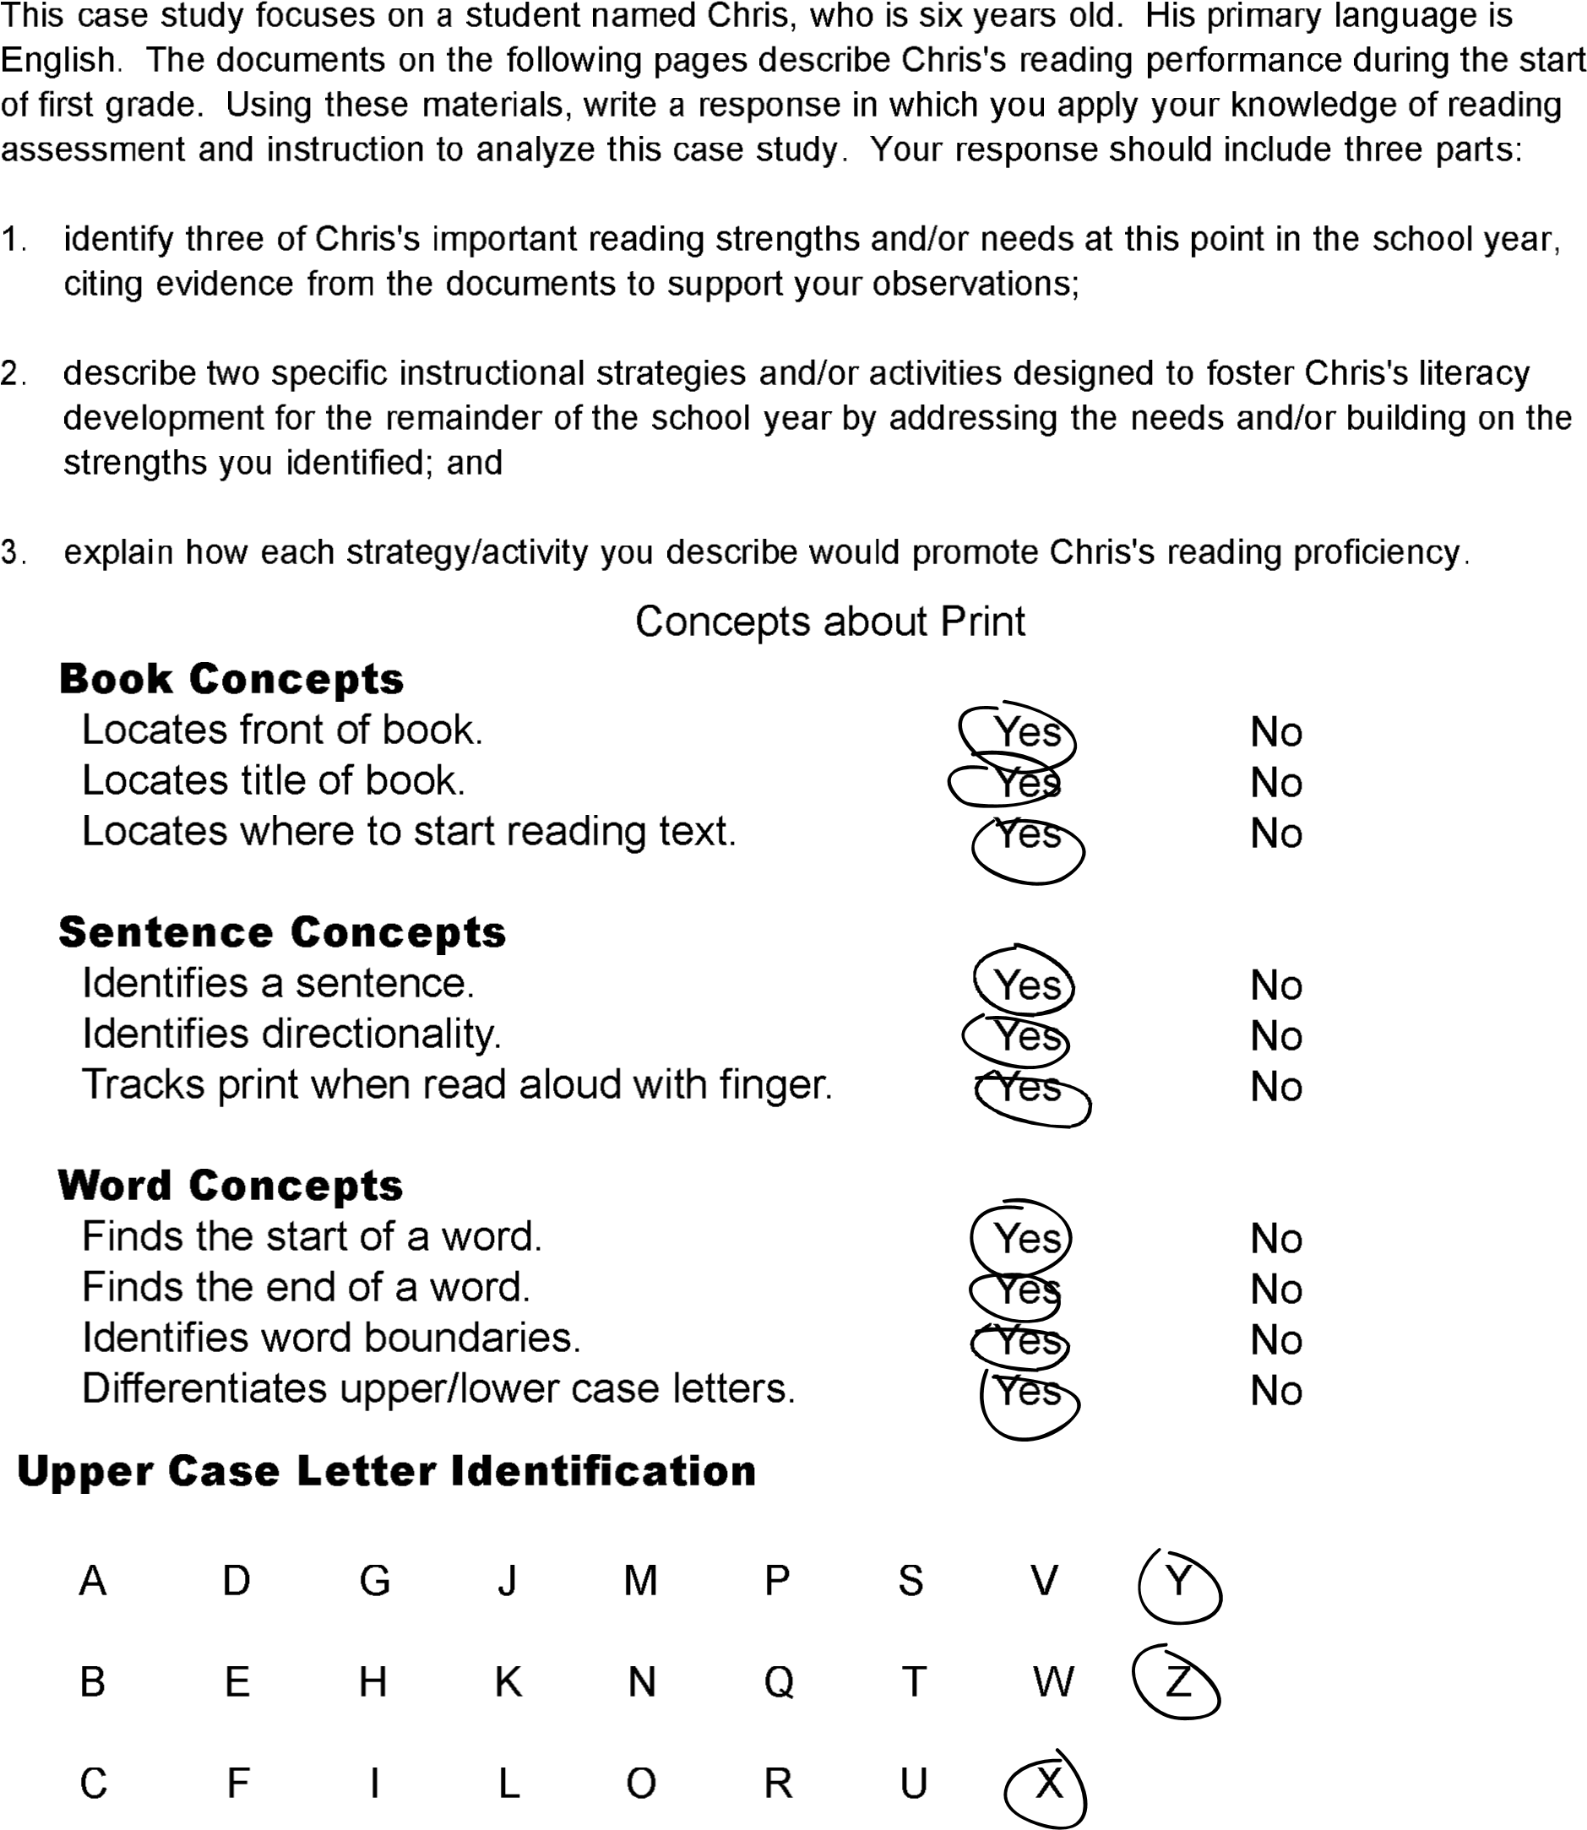
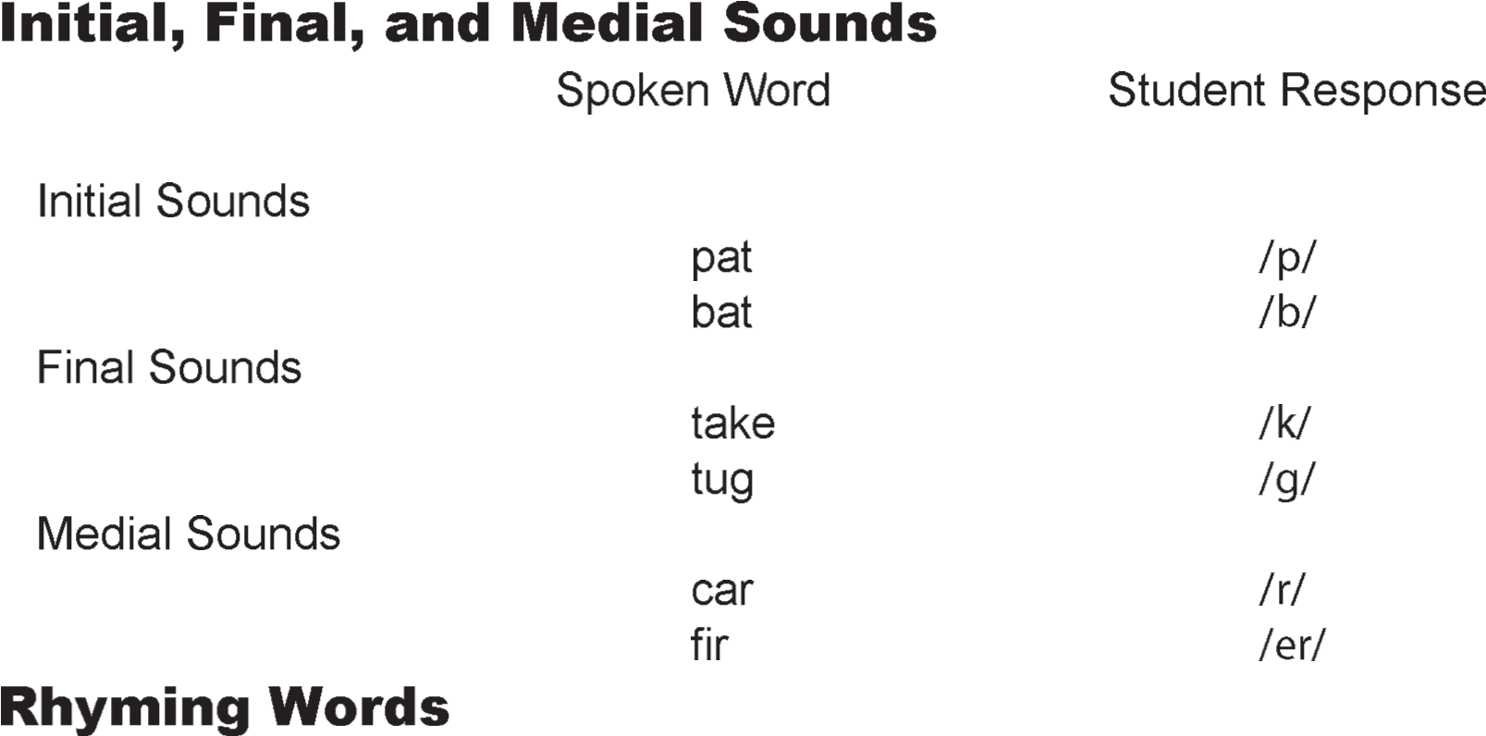
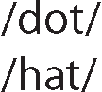
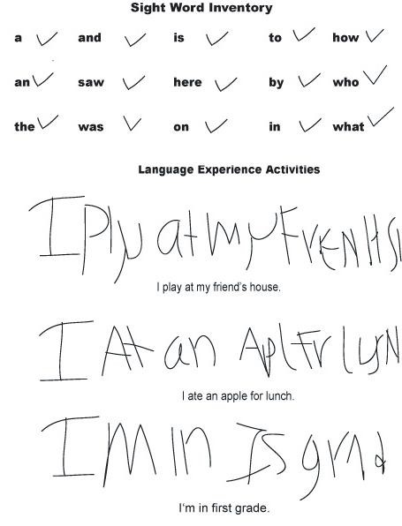
CHRIS CASE STUDY

Paragraph One Strength + Evidence
Chris has many strengths of an emergent reader. His concepts about print constitute one strength. As seen on his observation checklist, he understands all of the principle parts of a book, including how print carries meaning, where to start reading text, and which direction to read. He made only one minor mistake when he couldn't identify a mark of punctuation (a period).

Paragraph Two Strength + Evidence
Another strength is his phonemic awareness. Table 5.2 reflects Chris's ability to blend isolated sounds (e.g., /s/ /o/ /f/ /t/ as 'soft') and to segment spoken words into isolated sounds (e.g., 'tell' as /t/ /e/ /l/). This is important because the ability to blend and segment sounds is the foundation for learning to decode text and are the most advanced phonemic awareness
activities.

Paragraph Three Need + Evidence + Two Related Sub­needs
Chris’s strengths show that he is ready to move more fully into phonics instruction, since he can identify most letter by name and can segment well. Because his alphabet recognition text shows that he had difficulty visually discriminating b & d; i & j, and p & q (letters that are orthographically similar), this need would have to be addressed first. At the same time, he can then utilize his known rime, “at” (seen in his writing sample), to begin to learn to decode simple, cvc words using his secure consonants.

Paragraph Four Strategy + Steps + Benefits
To help Chris overcome his visual discrimination difficulties, I would use a multisensory technique. I would have Chris trace sandpaper letters (e.g., b & d), while thinking aloud. I would model how to say “down, up, and around” to form b and “around, up, and down” to form d, and then have him repeat it. Then, I would then have him identify these letters in a variety of texts to reinforce his learning in a new context. Finally, I would have him write each letter down each day until he can both read and write them fluently. Chris would benefit from these multisensory activities because he would learn to discriminate these problematic letters by using his sense of sight, touch, and hearing to learn to correctly identify them.

Paragraph Five Strength + Steps + Benefits
To help Chris learn to decode simple cvc words, I would focus on basic onset/rime instruction using his known consonants and known rime, ­at. I use a pocket chart with the consonants on one line and his rime on the other. We would work together to create and read new words with each of the known consonants. Finally, I would add his known sight words to a decodable sentence, such as, The cat sat on the mat, and ask him to read it. By looking at the word, saying the initial known consonants, and then adding the known rime, Chris would learn to decode simple, short­vowel cvc words using basic onset/rime instruction. He would also learn to read a sentence with these decodable words and known sight words in a sentence.
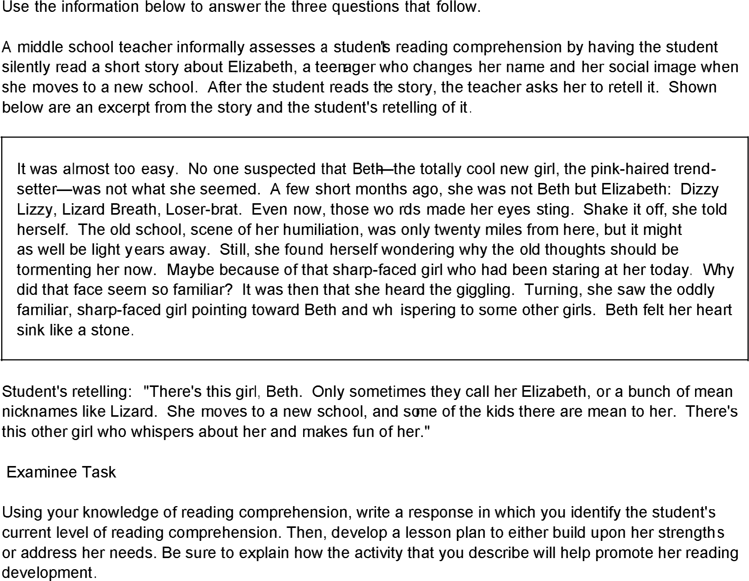

NARRATIVE TEXT LESSON NEED
This student is having trouble with the schema of narrative text. She is lost in the details of the story. For example, her retelling demonstrates that there is a girl named Beth who is facing a difficult situation in school. The problem is that the student does not understand how past events (flashback) may affect the future (foreshadowing), where the character was harassed at her old school and has been pretending to be cool at her new school, and that a “sharp faced girl” is about to find her out.
LESSON PLAN Strategy: Begin by focusing on narrative details that describe past and future events.
Materials:
Story Map
Learning Log
Pen Steps
- Display the graphic organizer and explain how it organizes details from the passage into past, present, and future, events:
Past | Present | Future
- Read the passage together and highlight details that support past, present, and future events. For example, highlight the details about Beth’s experience at the old school and the role of the “sharp faced girl” at the new school
- Work together to list the details in the story map:
Past | Present | Future
Elizabeth was tormented at her her old school | Elizabeth is pretending to be someone cool. | Elizabeth may be “outed” as uncool by the  “sharp faced  girl.”
- Ask her literal and inferential comprehension questions based on the story map. For example, ask her “What is Elizabeth trying to hide?” and “Why do you think that Elizabeth is worried?”
- Have the student re­write her retelling of the story in her learning log using the graphic oranizer as her guide.

BENEFIT
The story map will help the student understand the schema of narrative text. She will be able to see how details in the passage are organized into past, present, and future events, and she will understand how to answer literal and inferential comprehension questions using this tool Finally, she will be able to write accurate summaries about what she reads that will elaborate and extend her understanding of narrative text.
TANYA ESSAY
Following is an excerpt from a passage indicating the mistakes made by Tanya, a second grader, as she read the passage orally to her teacher. The passage was taken from a second­grade level basal reader.
t hr ee c r ane some p it
A thirsty crow flew to a big tree. He was looking for water to drink. There was a pitcher under the tree,
p it s p it
so he flew down to the pitcher. He looked into it. There was a little water in the pitcher.
c r ane t hr e e dr y p it c r ane dr y
The crow said, "I am thirsty. I will drink the water in this pitcher." But the crow couldn't drink the water. dr y
The top of the pitcher was too small. He couldn't get down to the water, so he couldn't have a drink. t his c r ane dr e ss c r ane
"I am so thirsty," the crow said. "I must have a drink. I must get that water." The crow flew to a big rock
p it
by the tree. He said, "I can't get down to the water because the top of the pitcher is too small. I have to get
p it p it dr y
the water up to the top of the pitcher. Then I can sit on the top of the pitcher and drink."
Ke y:
de le t ion long p ause r e ading r at e 51 wor ds p e r minut e inse r t ion shor t p ause
After the oral reading, the teacher asked Tanya about the passage. Following is an excerpt from their conversation.
Teacher: | Tanya, can you tell me in your own words what happened in this story?
Tanya: | There was a pit with water in it, and a crane wanted to get at the water. 'Cause he was dry.
Teacher: | What do you think he wants to do with the water?
Tanya: | Maybe swim or take a bath, or something. But the pit's too small. Cranes are really big birds. He should go find a pond or a lake.
Use your knowledge of reading to write an essay in which you assess Tanya's reading performance. In your essay:
- evaluate Tanya's reading performance, citing her strengths and needs as indicated by specific examples;
- select one area in which Tanya needs improvement and describe an explicit instructional strategy the teacher can use to address this need; and
- explain why the instructional strategy you identified is likely to be effective in improving Tanya's reading.

TANYA DECODING LESSON
STRENGTHS
Tanya recognizes irregular sight words like couldn’t and because. She also uses an initial consonant strategy to decode words. For example, she says three for thirsty, crane for crow, and dry for drink, indicating that she attends to initial consonants like digraphs (th) and blends (cr and dr).
NEEDS
Tanya’s greatest area of need is with rimes, because she substitutes words that are visually similar to what is in print. For example, she misses the “irsty” in thirsty, the “ow” in crow, and the “ink” in drink.
STRATEGY
I would focus on the rime –ow and teach her to decode words from this family.
MATERIALS:
INDEX CARD WITH THE RIME ­OW WRITTEN ON IT
INDEX CARDS WITH THE ONSET BLENDS CR, BL, SN, FL AT WRITTEN ON THEM
DECODABLE –OW TEXT: THE CROW FLIES IN THE SNOW.
STEPS
- DISPLAY ­OW RIME CARD AND MODEL SAYING THE DIGRAPH FOR THE CHILD BY POINTING AT THE DIGRAPH AND SAYING /OW/
- HELP THE CHILD TO ASSOCIATE THE PHONEME /OW/ TO THE DIGRAPH ­OW BY
ASKING HIM TO POINT TO CH­ AND READ THE DIGRAPH WHILE SAYING THE PHONEME.
- MAKE WORS WITH THE CHILD USING ONE OF THE ONSET BLEND CARDS. FOR
EXAMPLE, PAIR THE ONSET CR WITH THE RIME –OW TO MAKE THE WORD CROW.
- CONTINUE MAKING WORDS USING THE REMAINING BLENDS BL, SN, AND FL WITH THE RIME –OW TO MAKE THE WORDS BLOW, SNOW, AND FLOW.
- HAVE THE CHILD READ A LINE OF DECODABLE –OW TEXT ALOUD (THE CROW FLIES IN THE SNOW) AND CHECK FOR ACCURACY.
BENEFIT
THIS MAKING WORDS ACTIVITY SHOULD HELP TANYA READ WORDS WITH THEOW
RIME IN THEM, BECAUSE HE HAS BEEN TAUGHT TO ASSOCIATE THE PHONEME /OW/
WITH THE DIGRAPH –OW BY SEEING, SAYING, MAKING, AND READING ­OW WORDS USING DECODABLE –OW TEXT.
D
Domain Four
A sixth­grade teacher substitutes blank spaces for several nouns, verbs, adjectives, and adverbs in a newspaper article and distributes copies of the modified text to her students. Students work in pairs to determine reasonable and logical words that could fill in the blanks.
Using your knowledge of English language structures, write a response in which you explain one way that the activity described above can enhance the students' reading development.
Domain One
A new student enters a fifth­grade classroom. The teacher wishes to determine the student's independent reading level.
Write a response in which you describe an appropriate procedure for accomplishing this goal.

JUSTIFICATION ESSAY EXAMPLE: CLOZE ACTIVITY
A sixth­grade teacher substitutes blank spaces for several nouns, verbs, adjectives, and adverbs in a newspaper article and distributes copies of the modified text to her students. Students work in pairs to determine reasonable and logical words that could fill in the blanks.
Using your knowledge of English language structures, write a response in which you explain one way that the activity described above can enhance the students' reading development.
Form | Content
¶ How
¶ Why | 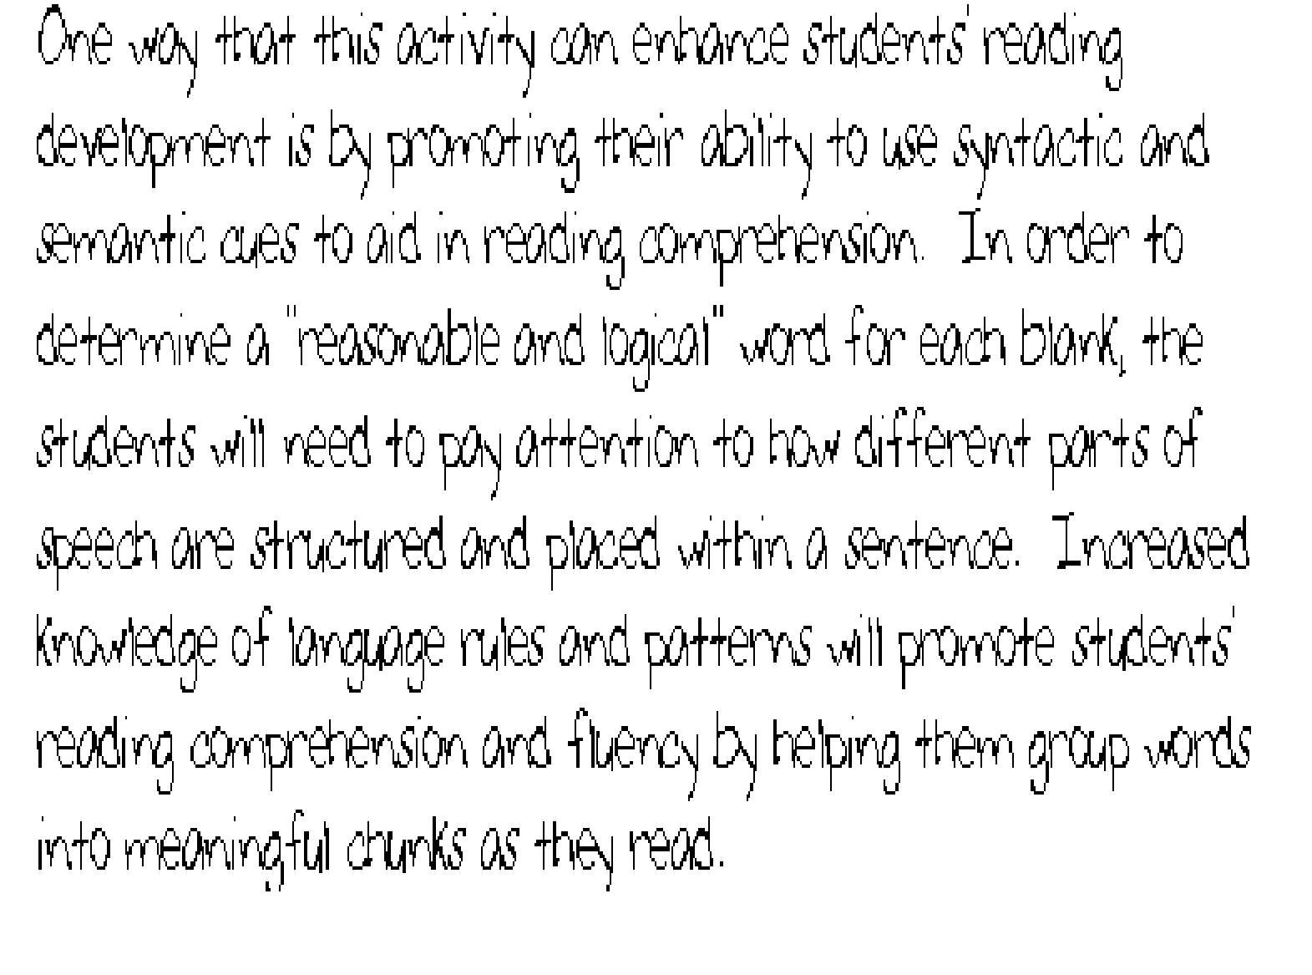
¶ Benefit

PROCEDURAL ESSAY EXAMPLE: THE INFORMAL READING INVENTORY
A new student enters a fifth­grade classroom. The teacher wishes to determine the student's independent reading level.
Write a response in which you describe an appropriate procedure for accomplishing this goal.
Form | Content
¶ What  ¶ Steps  ¶ Benefit | 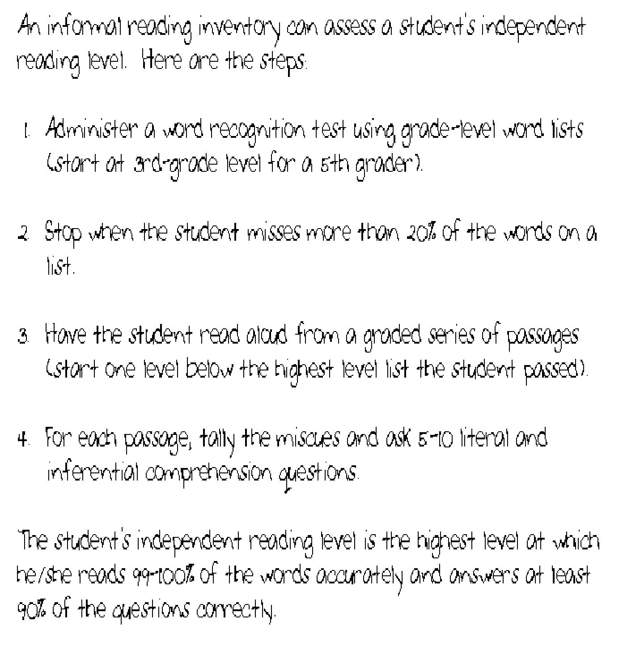

PART
CASE STUDY II
SPELLING LESSON
EXPOSITORY LESSON
WRITING AND PLANNING
˝¿‡ ·» ¿›» ˝‹«…§ ››•„†‡»†‹
This case study focuses on a student named Louise. Louise is a fifth grader who has been found to have normal vision and hearing. Her primary language is English. In October, the teacher observes Louise's reading of and responding to a short passage from a fifth­grade text.
The passage and the assessment information are reproduced on the following pages of data. Using these materials, write a response in which you apply your knowledge of reading assessment, instruction, and mentoring to analyze this case study. Your response should include the following information:
A description of three important aspects of Louise's reading, citing evidence from the case study to support your observations about Louise's strengths and needs.
A full description of two instructional strategies or activities that would be especially effective for the classroom teacher to use to improve Louise's reading ability. Be sure to address the needs and build on the strengths that you have identified for Louise.
An explanation of why each strategy/activity you described would be effective in improving Louise's reading proficiency.
˛ ¸ ˛
Printed below is a passage from a fifth­grade text that Louise has read silently.

If you have ever spent time watching an animal, you have probably seen it doing a number of different things. If you have ever watched ducks in a park, for example, you may have seen them flying, landing in a pond, swimming, or ducking their heads under the water. You may also have noticed that when people sat down on a bench near the pond, the ducks sometimes swam toward them looking for food.
Some of a duck's behaviors, such as swimming or ducking its head under the water, are •†›‹•†‰‹•“»behaviors, things that ducks do automatically. Other behaviors, such as seeking food from people, are things that the ducks have ·»¿fi†»….
Many animals demonstrate both kinds of behaviors—even animals that you might not think of as being able to learn things.
The southern toad, for example, eats insects. When a dragonfly flies by, the toad opens its mouth wide, lunges forward, and snaps it up. But how does the toad know that it should eat insects? Did it learn this from its parents? No, the toad behaves this way by instinct. It eats insects automatically, because this behavior is
a trait, or characteristic, that it has inherited. It is something that the toad was born knowing how to do.
But even though a toad eats insects automatically, it can still learn something about eating. For example, it can learn what it likes and what it doesn't like. Scientists have observed that if a southern toad tries to eat a bee and is stung, the toad will no longer try to eat bees. A toad that has been stung by a bee will recognize a bee the next time it sees one and will simply ignore it, even if it flies right by the toad's nose. The toad has changed its behavior based on experience. That is, it has ·»¿fi†»….
The next time you're watching an animal, see if you can distinguish between things that it does instinctively and things that it has learned from experience.

Before asking Louise questions about the text, the teacher has her read the beginning of the fourth paragraph aloud. As Louise reads, the teacher uses another copy of the text to take notes on Louise's performance. Printed below are the teacher's notes.
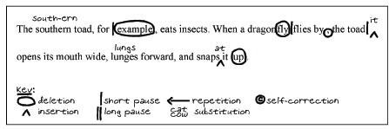
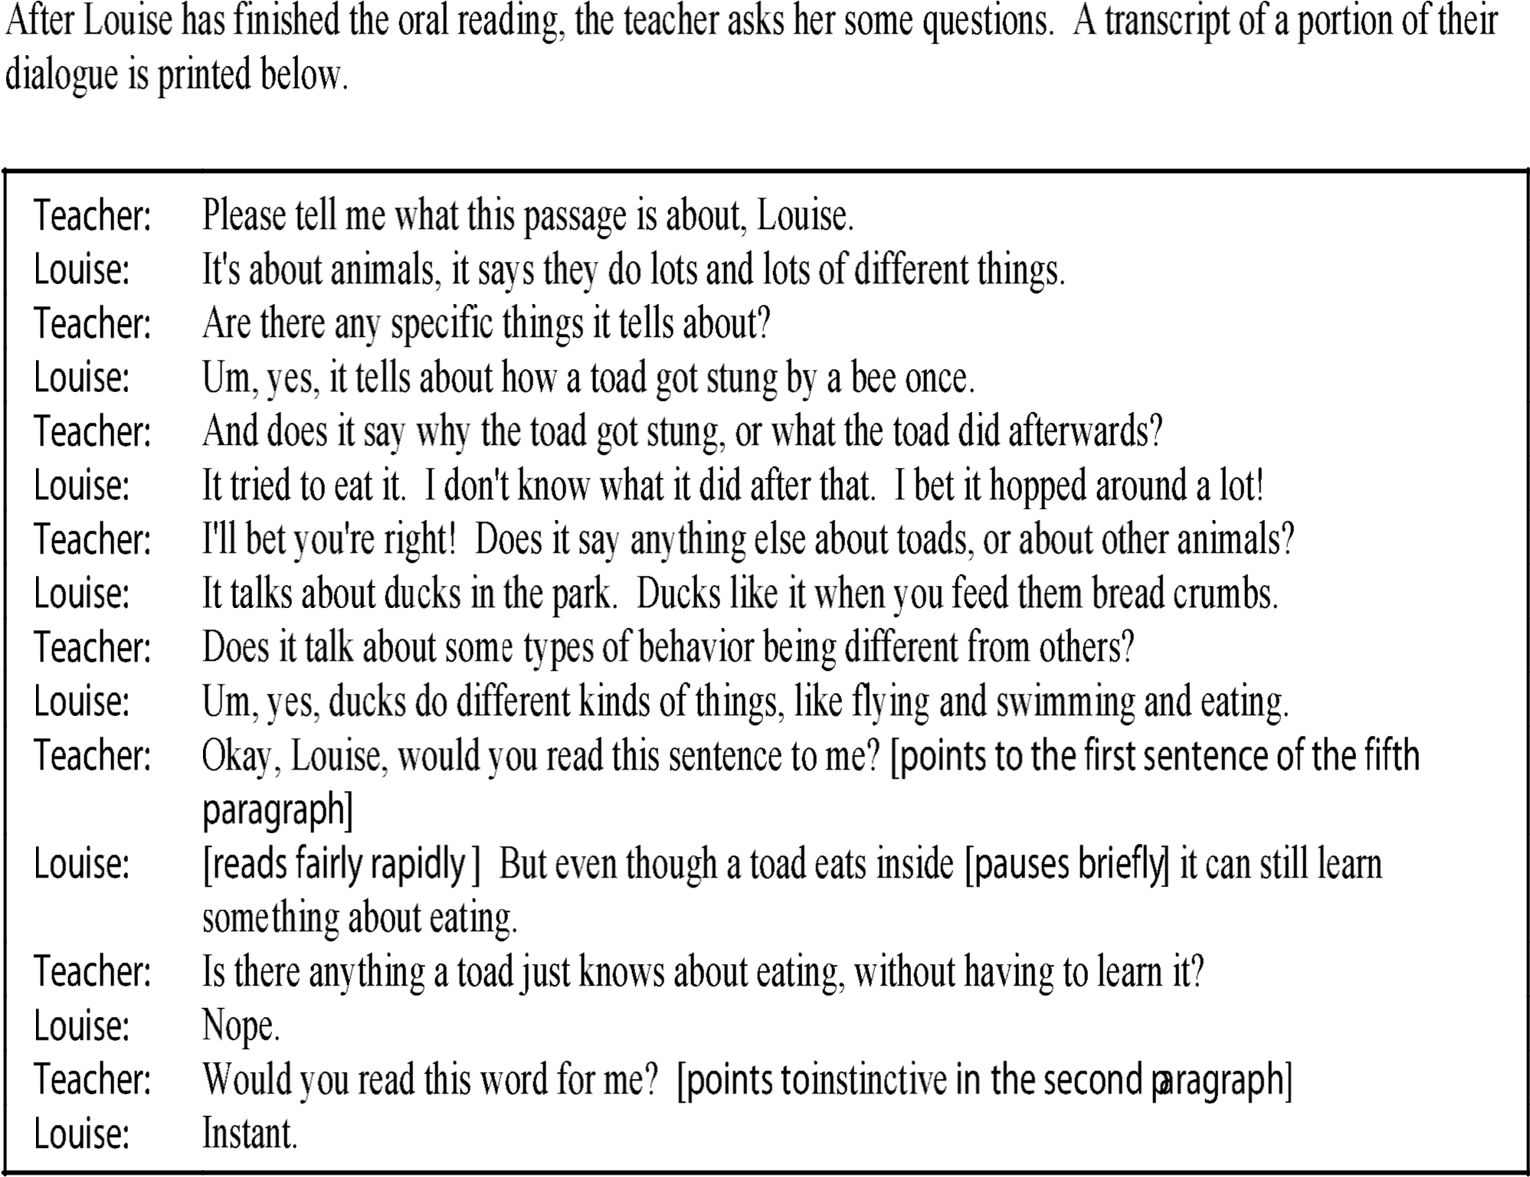
˛ ˝
Printed below is an excerpt from the teacher's notes documenting informal observations related to Louise's reading activities.
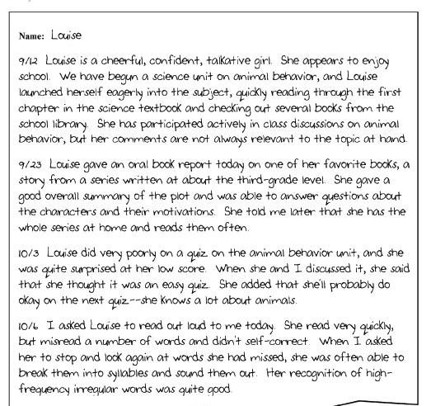
˝˝ ˝˝
˛ ˝¸
˝
Louise's reading scores taken in the spring of fourth grade is shown below.
˛»¿…•†„ ˛»›«·‹› | –«•›»ø› ›‰–fi» | ˝‰–fi» fi»fl«•fi»… ”–fi  – ¶»‰‹•“» ‡¿›‹»fi§
1. Word Meaning | 4/6 | 5/6
2. Supporting Ideas | 2/8 | 6/8
3. Summarization | 1/6 | 5/6
4. Relationships and Outcomes | 2/6 | 5/6
5. Inferences and Generalizations | 4/10 | 8/10
6. Point of View, Propaganda, Fact and Nonfact | 1/4 | 3/4
Louise's performance on a language arts quiz is shown below.
˝ •·· | «‡ »fi –fifi »‰‹
Recognizing prefixes and suffixes | 4 out of 8
Separating root words from affixes | 3 out of 6
Dividing words into syllables | 3 out of 6
In the first two weeks of school, the teacher met with students individually and asked them to read aloud words from a set of flashcards. The checklist below shows Louise's performance on a portion of this task.
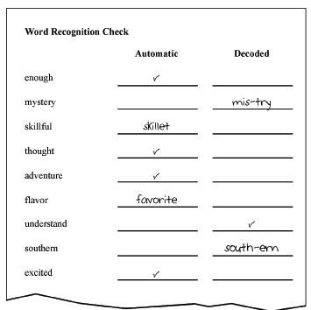

LOUISE CASE STUDY Strength One
Louise’s first strength is that she fluently decodes third grade narrative text. The teacher notes of 9/23 indicate that she can read and summarize decodable text that is written at a third grade level and answer questions about character motivations. This is a very important strength, because it shows that if she is fluent and has the correct schema (narrative in this case) she will be able to comprehend what she reads.

Strength Two
Louise’s second strength is that she has some word identification skills. The teacher notes of 10/6 also indicate that she can recognize high­frequency, irregular sight words such as thought, adventure, and excited. She can also and break unfamiliar words into syllables. She was able to syllabicate “mystery,” “southern,” and “understand.” She was also able to recognize the initial onset in “skilful” and used the initial letter of “flavor” to guess at the word.

Problem + Need A + Need B
Louisa’s need is with comprehending grade­level expository text both literally and inferentially. The teacher dialogue and her SAT9 Reading scores reveal that Louisa has very limited literal comprehension of expository text, because she read it as if it were a narrative story. This is because she does not know how to follow the schema (structure) of expository text, since she was looking for characters and plots in the passage about animal behavior. Also, she is unable to fluently decode and reassemble polysyllabic words that are often found in upper­level, content­area texts (e.g., she read insect as inside and instinctive as instant). Therefore, the areas upon which I would focus would be expository schema and polysyllabic words

Need A + Lesson Plan One + Benefit One
To help Louisa read for comprehend expository text literally, the teacher needs to help the make the schema (organization) of expository text concrete. I would use a graphic outline to help for this purpose. First, I would put the central idea in a circle on a piece of paper (in this case, it is animal behavior). Second, I would have two branches off the circle, one being instinctive behaviors and the other being learning behaviors. Third, Louisa and I would read the passage together and categorize the details from each paragraph into either instinctive behaviors or learned behaviors. Finally, I would ask Louisa literal and inferential comprehension questions based on the passage and have her use the graphic outline as a guide. This activity would make the schema of expository text concrete, because she can visualize how the details of the passage are organized and can use a strategy to answer comprehension questions.

Need B + Lesson Plan Two + Benefit Two
A good strategy to use in order to help Louise with polysyllabic words would be to focus on polysyllabic words. I would take a polysyllabic word for her word recognition check, such as understand, and teach her how to both syllabicate and reassemble it. I would write its syllables word onto three index cards as follows: the first card would have the UN, the second card would have DER, and the third card with STAND. Louise and I would associate the correct phoneme chunks to these syllables and practice making words from them (UN + DER) and (UNDER + STAND). Finally, I would have her read a sentence with understand in it. The benefit of this activity is that it teaches Louise to associate phoneme chunks to words, along with how to not only syllabicate but also reassemble words by seeing, saying, and manipulating syllables.
Use the information below to answer the two questions that follow.
A seventh-grade student silently reads the passage printed below.
People all around the world are both fascinated and repulsed by snakes, with their unusual shape, habits, and way of getting around. Many cultures regard snakes as special, sacred animals. Even so, the population of snakes is decreasing as humans move into their environment. Often, snakes are hunted for their skins and their meat, or for recreation.
Snakes are found in all parts of the world except near the poles. They are cold-blooded animals, which means that their body temperature goes up and down along with the temperature outside. They are able to survive cold seasons by staying very still and slowing down their digestion and circulation. Once it warms up, they begin to move, sense the world around them, and look for food.
Rodents and other small animals are the main food source for snakes. Even though snakes are able to slither into the holes and burrows where these animals hide, they must spend most of their time, and most of their energy, looking for food. As people living in the country have found out, when the snakes in an area are all gone, the number of mice and other rodents goes up.
Though many snakes are famous for their dangerous venom, other types have become popular pets. Unfortunately, this is yet another cause of the decreasing number of snakes still living in the wild.

When the student finishes reading, the teacher asks her questions about the passage. Printed below is an excerpt from this conversation.
Teacher: What is this passage about?
Student: It's all about snakes. Where they live, what they eat, stuff like that.
Teacher: What did you learn about where they live?
Student: They live all over the place. They don't really get cold. That's why they can live anywhere, pretty much. Wherever there's food. In some places people have gotten rid of all the things they eat, like mice. They use mousetraps and stuff. So the snakes don't live there anymore.
Teacher: Did you learn anything else about snakes?
Student: In some religions they're really important animals. And lots of people have them as pets. I think people like them for pets because they like to have things nobody else has, and things that are kind of dangerous. Jake has one, and he's just trying to be cool.
Using your knowledge of reading comprehension, write a response in which you:
- identify onereading comprehension need demonstrated by the student;
- describe an instructional strategy or activityto help address this need; and
- explain why the strategy or activity you describe would be effective for this purpose.

EXPOSITORY TEXT LESSON
The student does not comprehend grade level expository text inferentially. For example, when he was asked, “What did you learn about where they (snakes) live?” He answered, “They (snakes) live all over the place and they do not get cold”. He invented details about what he read, thus demonstrating his lack of understanding of the passage.
Begin by focusing on the schema of expository text and the organization of details.
Materials:
- Graphic outline
- Pen
- Learning log
Instruction
- Display graphic outline and explain how it is used to organize expository text.
For example:
  - topic sentence
    - detail
    - detail
  - topic sentence
    - detail
    - detail
- Read the passage together, highlight the topic sentence and find the supporting details for each paragraph.
- Work together to fill out the graphic outline. For example:
I. Snakes and their habitat.
      - People and snakes.
      - Snake’s habitat.
      - Snake’s population.
- After completing the graphic outline ask the student literal and inferential questions about the passage.
- Have the student write a summary of the passage in his learning log using the graphic organizer outline.
Using a graphic outline to understand expository text makes the schema concrete and visual. It also shows how the details are organized in the passage. This strategy will help the student elaborate and extend his understanding of the passage because the expository text has been presented to him in a concrete and visual manner.
J

 | 
 | 
 | 
 | 
 | 
 | 
 | 
 | 


SPELLLING LESSON
The student’s spelling assessment revealed that she is at the phonetic stage of spelling when she spells the words quick and some (e.g., kwk, and sum). The assessment also revealed that the student is at the transitional level when she spells “ow” and silent “e” words. For example, she spelled “bloe” for blow, “snoe” for snow, “caek” for cake and “keit” for kite.
Strategy: Begin by focusing on encoding silent “e” words (e.g., cake, kite, etc.) Materials:
Set of cards with words “mat, rat, and kit” written on them.
Separate note card with the letter “e” written on it.
White board and pen.
Pocket chart.
Instruction:
- Display the note card with the word “mat” to the student on the pocket chart.
- Add the note card with the letter “e” in front of the word “mat” to make the word “mate”
- Teach the rule that silent “e” makes the vowel say its name as in “mate”
- Add the note card with letter “e” to the other words (rat, kit) and have the student read each new word aloud.
- Have the student write the new words on the white board (mate, rate, kite) and have her read each word aloud.
- To check for understanding say the word “cake” and have the student spell it and to write it down independently.
Benefit
This silent “e” word making activity will help the student make the transition from the transitional spelling stage to the conventional stage for silent “e” words, because he has been taught the rule and been asked to apply it by seeing, saying and writing silent “e” words.
F


Classroom Planning
A new teacher asks you for help in designing literacy centers for her first grade students.
Using your knowledge of classroom planning, write a response in which you detail ideas that the teacher might consider in this endeavor.
CLASSROOM PLANNING

WHAT
I would tell the teacher to design the learning centers around the four skills: reading, writing, listening, and speaking.

STEPS
- The reading center should be in a quiet area of the room and include various materials for students to read that match all the students’ interests, reading levels, and cultures. It should be well lit and inviting.
- The speaking center should be in a place where the students can make noise. They should be able to play games like sight word bingo and other activities that work on their word recognition skills through games and fun.
- The listening center should also be in a quite place where the students can work on fluency by listening to books on tape and following along. There should be adequate resource for each child at the center and everything should function properly.
- The writing center should be place where the students will write to characters and practice other skills. For example, they can learn how to write letters, address envelopes, and write on stationery, along with extending their understanding of what they read.

BENEFIT
Organizing centers around the four skills will help all of the students develop their abilities in these areas, because each skill area has an impact on reading development.

WRITING LESSON
The student’s language experience sample shows confusions with common homophones (words that sound the same, but are spelled differently and mean different things. For example, she confuses then and than, it’s and its, and to and too at various points in the essay.
To fix these confusions, I would select several homophones, like to, too, and two and display them on index cards. Then, I would teach her that to is a preposition as in go to the store, two indicates number, and too means also. I would then present her with the following sentences:
I go ___ the store. I want _____ ice cream cones. Jan likes ice cream, _____.
I would have her complete the cloze activity to demonstrate her understanding before having her write the sentences in her learning log. The benefit of the cloze activity is that she will learn to distinguish common homophones, along with learning how to use them correctly by seeing, saying, and manipulating them in this activity.
K

DOMAIN ONE Assessment
Using your knowledge of standardized assessments, write a response in which you explain the relative benefits and detriments of using these types of exams to assess a student’s reading ability.

Portfolio Question
Using your knowledge of formal and informal assessment, select one type of assessment instrument or method and explain its advantages or disadvantages.

Selecting Literature
A fifth grade teacher with children who read well below grade level (second grade) as well as above grade level (seventh grade) asks you for advice on selecting literature for her classroom. Using your knowledge of creating an environment for the development of literacy, describe things that the teacher could consider when selecting texts for her students.

Classroom Planning
A new teacher asks you for help in designing literacy centers for her first grade students. Using your knowledge of classroom planning, write a response in which you detail ideas that the teacher might consider in this endeavor.

Homogeneous and Heterogeneous Grouping
A second­grade teacher reviews the assessment results for her students on a variety of tasks:
Student | Decoding | Decoding | Fluency | Brainstorming
 | Blends | Inflections | (Intonation) | Ideas
Timmy | 1/5 | 6/6 | Adequate | Emergent
Mary | 5/5 | 3/6 | Adequate | Emergent
Jimmy | 2/5 | 6/6 | Adequate | Emergent
Linda | 5/5 | 2/6 | Adequate | Emergent
Johnny | 3/5 | 6/6 | Adequate | Emergent
Cindy | 5/5 | 2/6 | Adequate | Emergent
Billy | 2/5 | 6/6 | Adequate | Emergent
Christine | 5/5 | 6/6 | Inadequate | Emergent
Betty | 5/5 | 6/6 | Inadequate | Emergent
Christopher | 5/5 | 6/6 | Inadequate | Emergent
Using your knowledge of grouping students for instruction, write a response in which you explain how the teacher can group the students most effectively for skill and strategy instruction in her classroom. Be sure to cite evidence from the teacher’s report to justify your response.

Building Fluency (Answer)
A third grade student reads with a high degree of accuracy, but at a slow rate with almost no intonation. Using your knowledge of developing fluency, write a response in which you describe procedures for addressing both issues with developing readers. Domain Four

Motivating Children
Billy is a fifth grader who performs at an average level in your class. While he regularly shows a high aptitude for reading on standardized assessments, his in­class performance does not reflect his abilities. Using your knowledge of motivating children in the reading process, write a response in which you describe one way that you can encourage students like Billy to become more engaged and motivated readers.

Readers Theater
Students in a fourth­grade class participate regularly in Readers Theatre performances. The teacher begins by selecting a story at an appropriate level of difficulty and converting it to a script. The teacher models an expressive reading of the story on which the script is based. After discussing the story with students, the teacher offers a minilesson on how to make a story "come alive" through expressive reading of a Readers Theatre script.
The teacher then distributes a copy of the script to each student in the group. The students practice reading aloud the script independently or with a partner. Then they rehearse the script as a group, reading their assigned roles and responding to coaching from the teacher. In subsequent rehearsals, the students switch roles, until every student has had a chance to perform each role at least once. Over the course of the week, the students rehearse the performance by reading the script aloud at least 12 times. The day before the performance, students rehearse their final roles. The performance, which requires no costumes or props, is presented to an audience of classmates, family members, school staff, or other groups of students.
Examinee Task
Write a response in which you explain one way that the approach described above can help promote students' reading development.

Language Experience Approach
A first grade teacher has her students visit the zoo to see animals and broaden their experiences. Describe an activity that the teacher can use in class to improve the students' literacy development after returning to the classroom.

ESL Instruction
A new teacher asks you for guidelines for using TPR in her classroom.
Using your knowledge of ESL activities, write a response in which you describe a procedure for accomplishing this goal.

