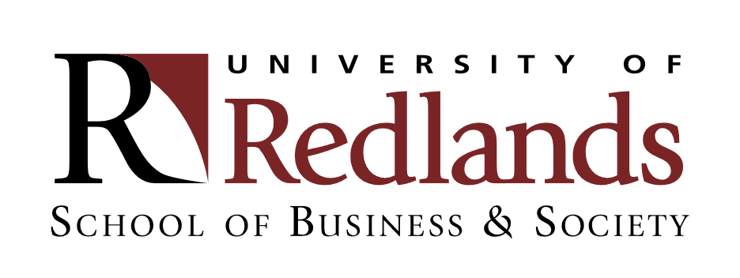

SBUG 470: Sustainable Business in Italy & Slovenia (Venice, Trieste, and Ljubljana)
Program Dates & Duration: May 15-25, 2024. Pre-travel virtual class sessions and post-travel assignment submissions required. Enrollment limit 8 (CAS).

Course Fee
$3,200

Included in Course Fee
Lodging in business class hotels (double occupancy), breakfasts, wifi, ground transportation, transfers between cities/hotels during the program, business and academic visits, welcome and farewell dinners, and select cultural excursions.

Beyond Course Fee
Shopping, meals not included in the program, and personal expenses. Airfare (may be arranged through School of Business & Society recommended travel agent). Airport-hotel transfers.
Course Description
The natural beauty and historic cities of the northern Adriatic will be our classroom as we explore how business is conducted sustainably in this stunning European region. Join us as we travel from the dreamy canals of Venice, to the vibrant coastal port city of Trieste, to Slovenia’s majestic lakes and castles. Discover the ways tradition and innovation combine to shape sustainable futures in the changing business landscape. We will see up-close the centuries-old craft of luxury velvet-making in Venice, hear from leaders at a Venice-based sustainability incubator, learn trade strategy from an Italian wine global exporter, and network with entrepreneurs in Slovenia—Europe’s designated “green” capital.

This course combines pre-travel virtual class sessions with overseas seminars, company/institutional visits, and cultural exposure. The primary focus of this travel course to Italy and Slovenia will be sustainable business. What sustainable business issues and prospects are particularly relevant for Italy and Slovenia? What are the strengths & weaknesses of industries in this region? What will the future hold? What can businesses outside of the regions studied (e.g. U.S. businesses) learn and do to build sustainable options?

Prerequisite: Bus 226 or 228 (or permission)

Contact
Allison Fraiberg, Ph.D.
Professor of Communication & Cultural Studies School of Business & Society
allison_fraiberg@redlands.edu
949.444.8908 (text & voice)

Tommi Cahill, M.F.A.
Professor of Art
tommi_cahill@redlands.edu
909-748-8822

