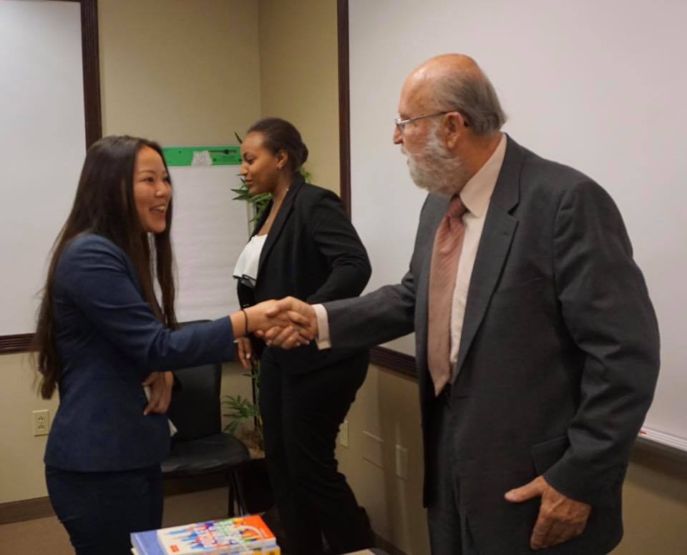
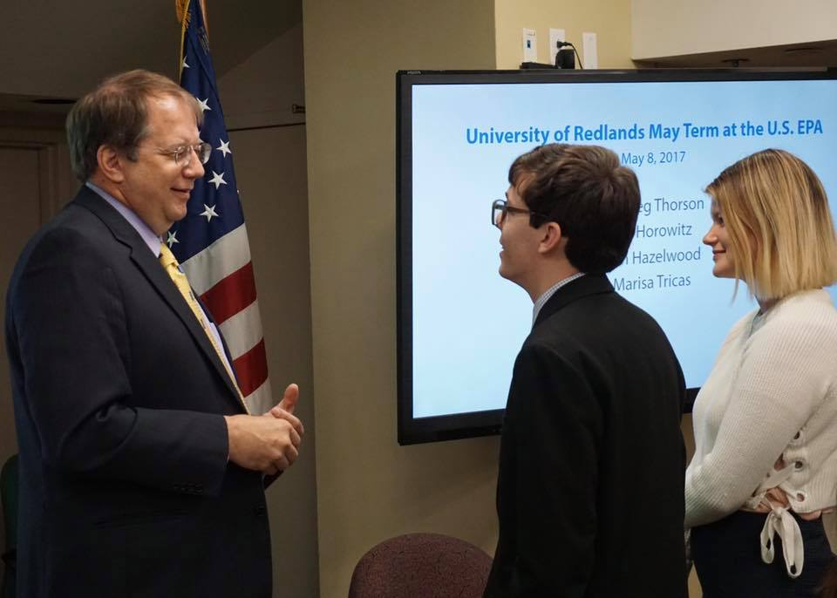
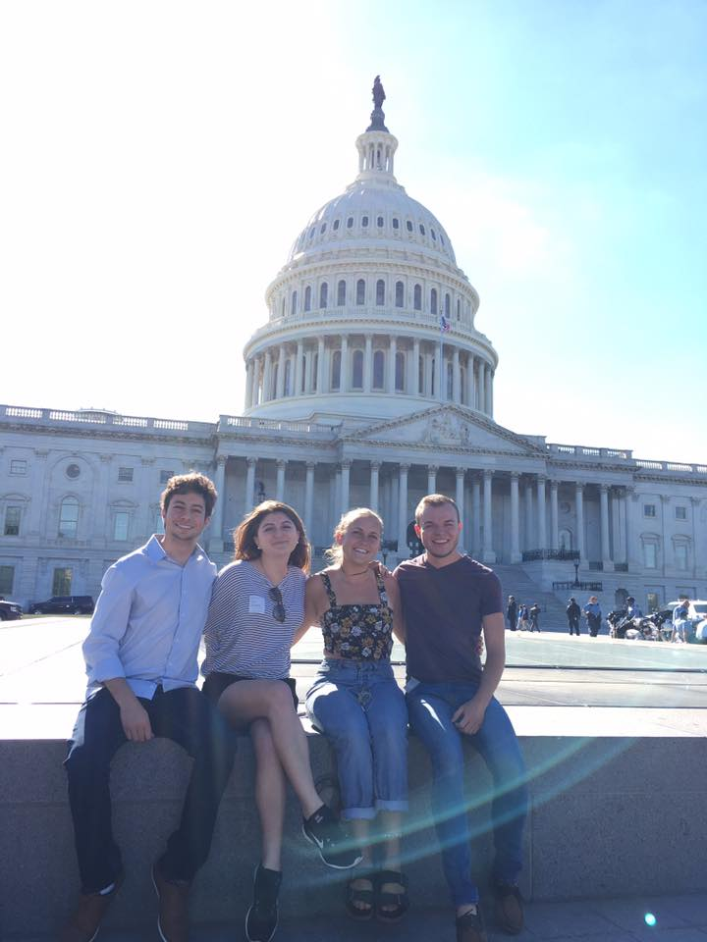

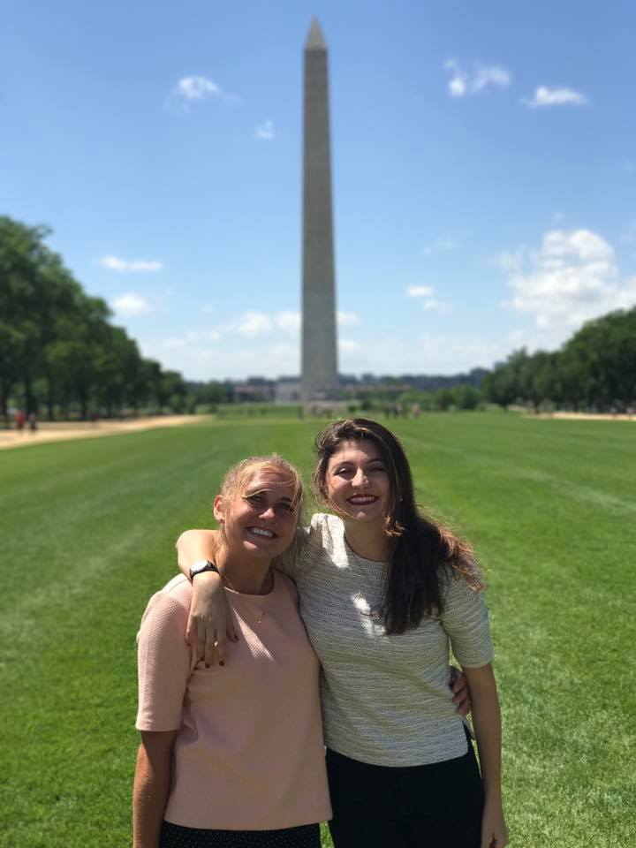
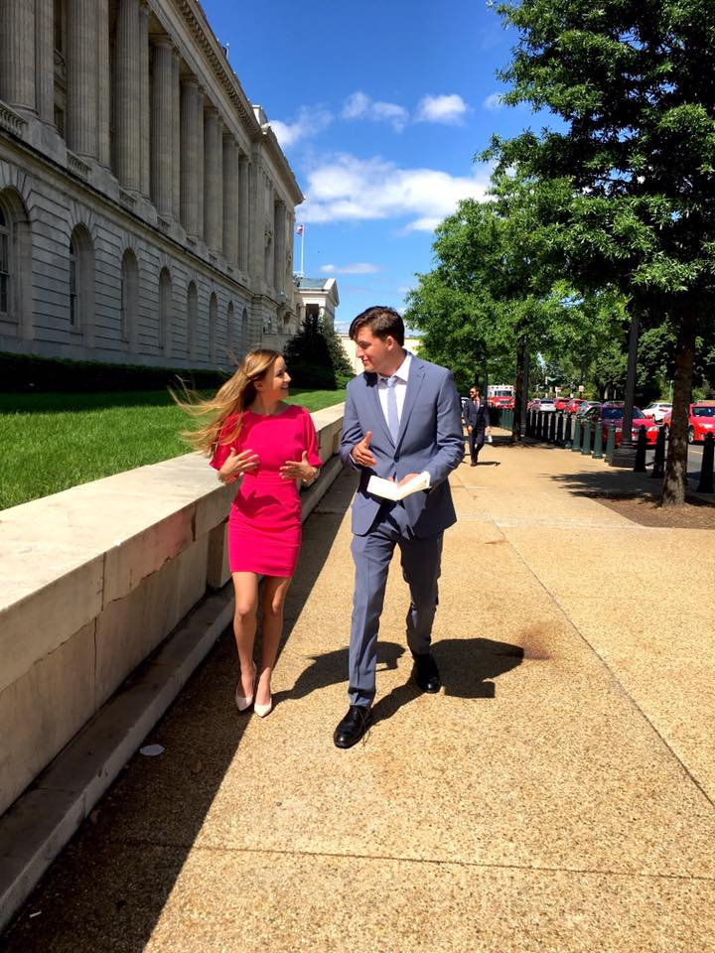
POLI 257: Policymaking in Washington D.C.

Spend May Term in Washington D.C.!
  - Join us this May session as the University of Redlands returns to Washington!

  - University of Redlands 1200 E Colton Ave, P.O. Box 3080, Redlands, CA 92373 Tel: 909-793-2121

Live in the heart of Washington D.C. Meet governmental leaders. Hear engaging speakers. Visit politically and historically important places. Network with the many University of Redlands alumni working in our nation’s capital. Explore at your own leisure!  Prerequisites:  None. Open to all majors and classes!  Course Dates:  May 6th – May 30th, 2024  Course Fee:  $2450  Includes housing and all mandatory activities.  Airfare, local transportation, food, and optional activities are not included. Please budget an additional $1,500-$2,000 for these items.  Financial aid is available!  Want to Know More?  Attend the May Term in Washington Information Night on Monday, September 25th at 7:30PM in  Hall of Letters 317.  How to Register:  Contact Sara Thompson, Department Coordinator for the Political Science Department Office at  (909)748-8545.  Course Application Deadline:  Due Wednesday, October 4th |  | Sign Up Now for This Exceptional Opportunity!  For more information, please contact:  Professor Thorson (909) 748-8636  Greg_Thorson@redlands.edu  OR  Graeme Auton (909) 748-8595  Graeme_Auton@redlands.edu

