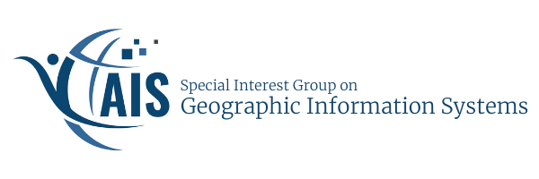

ICIS Conference (International Conference on Information Systems)

Pre-Conference Workshop - Location Analytics and Competitive Advantage of Place: Theory And Practice

San Francisco, CA
Thursday, December 13, 2018, 8:30am – 12:30pm

Location analytics and GIS have become deeply integrated into society, transforming every aspect of human’s life. These technologies move the Internet beyond cyberspace to the location-aware Internet of Things (IoT), so-called Location of Things (LoT). They enable connections among objects whether they are fixed (such as appliances at homes and warehouses) or moving (such as cars, pedestrians, and trucks), helping cooperation of these objects and the analysis of their mobility patterns in space and time. This workshop focuses on location analytics and spatially-aware IoT, which bridges people, data and things, thereby making a collaborative economy more efficient and effective. While locational technologies can create value, the very success of these technologies also raises issues related to the use of spatial data, such as privacy and trust. This workshop, including the keynote talk by an industry leader, highlights the emerging opportunities and issues in location analytics and discusses how these technologies can enable the growth and success of businesses in the collaborative economy. In the afternoon part of the workshop, contributed papers will be presented on a variety of topics related to emerging opportunities and issues with regard to location analytics and GIS at large.

Sponsored by AIS’s Special Interest Group in Geographic Information Systems.

ORGANIZERS AND PRESENTERS:
Brian Hilton, Claremont Graduate University James B. Pick, University of Redlands
Avijit Sarkar, University of Redlands

Hindupur Ramakrishna, University of Redlands Dan Farkas, Pace University
Namchul Shin, Pace University

INDUSTY KEYNOTE TALK: TBD
WORKSHOP REFEREED PROCEEDINGS AVAILABLE in the AIS eLibrary: https://aisel.aisnet.org/siggis/

============================================================= PROGRAM OF PRE-ICIS WORKSHOP

8:00-8:30am PRE-WORKSHOP COFFEE/TEA

8:30-8:45am Introduction to Workshop and Acknowledgments

8:45-9:30am Overview of Location Analytics and Location of Things 9:30-9:45am Coffee/Tea Break
9:45-10:35am Keynote Professor Yan Li, Claremont Graduate University

10:35-11:10am Breakout into Discussion Groups: Research Opportunities for IS/IT Researchers in Location Analytics and GIS at large

11:10-11:30am Sharing Research Ideas from Discussion Groups 11:30-12:20pm Contributed Peer-Reviewed Research Papers Session
12:20-12:30pm Workshop Summary

