* ***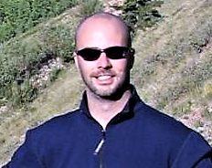***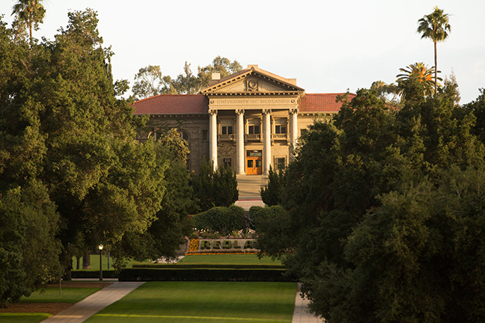****../../../Assets/Logos/School%20of%20Business/1815/Style%201/RedlandsSB_Style1_white%20RGB%2072ppi.png

**Tony Grubesic  
Tony H. Grubesic is the college professor of policy and analytics and the Director of the Center for Spatial Reasoning & Policy Analytics, in the College of Public Service & Community Solutions at Arizona State University. His research and teaching interests include geographic information science, transportation, urban health, crime, regional development, environmetrics, public policy evaluation and spatial statistical methods. He is the author of more than 130 peer-reviewed research articles and has secured more than $8.3 million in research funding over the past six years from a variety of agencies, including the National Academies of Science, the National Science Foundation, the National Institutes of Health, and the Institute for Museum and Library Services.**

**Grubesic currently serves as Editor-in-Chief of the International Regional Science Review, and Associate Editor for both Telematics and Informatics and The Information Society. Grubesic holds a Ph.D. in Geographic Information Science from Ohio State University.**

**Learn more about the Center for Business GIS**

**and Spatial Analysis**

[**www.redlands.edu/gisab**](http://www.redlands.edu/gisab)

**About the event**

Google Fiber, which provides ultra-high-speed fiber-to-the-premises (FTTP) and speeds up to one hundred times faster than pre-existing broadband services, is available in nine cities in the United States. Although Alphabet announced plans for expansion in 2015, recent budget cuts have cast doubt on these prospects.  One of the most vexing aspects associated with the rollout of Google Fiber is the lack of corporate transparency concerning issues of service provision.  Alphabet refuses to disclose any information on service footprints, the characteristics of populations served by Fiber, or the nature of their provision agreements with local municipalities.  This type of obfuscation drastically limits the ability of policy analysts to evaluate outcomes (both positive and negative) associated with service provision and the digital divide, more generally.  The purpose of this paper is to detail a novel data mining technique, combined with exploratory spatial data analysis (ESDA), to uncover the geographic intricacies of Fiber service for both Provo, Utah and Austin, Texas.  In addition, we leverage basic statistical techniques to explore issues of Fiber access and equity, accounting for the vast differences in socio-economic and demographic status of the populace served/not served for both cities.  Policy implications are discussed.

**RSVP to Ms. Christine Mee at** [**gisab@redlands.edu**](mailto:gisab@redlands.edu)

**By January 16, 2018**

**Tuesday, January 23, 2018  
11:30 a.m. – 1:30 p.m.**

University of Redlands Main Campus   
Hall of Letters  
Lunch served at 11:30 a.m.

University of Redlands Main Campus   
Hall of Letters Room 100  
Lunch served at 11:30 a.m.

**Exploring the Geographic Footprints of Google Fiber in Provo, Utah and Austin Texas: Implications of the Digital Divide**

**Tony Grubesic, Director for the Center for Spatial Reasoning and Policy Analytics, Arizona State University**

Winter 2018 Speaker Series

**Center for Business GIS**and Spatial Analysis

**Cyrus Shahabi, Ph.D.**

**Cyrus Shahabi** is Professor of Computer Science and Electrical Engineering and the Director of the Information Laboratory (InfoLAB) at the Computer Science Department and also the Director of the NSF's Integrated Media Systems Center (IMSC) at the University of Southern California (USC). He is also the director of Informatics at USC Viterbi School of Engineering. He was the CTO and co-founder of a USC spin-off, Geosemble Technologies, which was acquired in July 2012. Since then, he founded another company, ClearPath (recently rebranded as TallyGo), focusing on predictive path-planning for car navigation systems. He received his B.S. in Computer Engineering from Sharif University of Technology in 1989 and then his M.S. and Ph.D. Degrees in Computer Science from the University of Southern California in May 1993 and August 1996, respectively. He authored two books and more than two hundred research papers in the areas of databases, GIS and multimedia with more than 12 US Patents.