* ***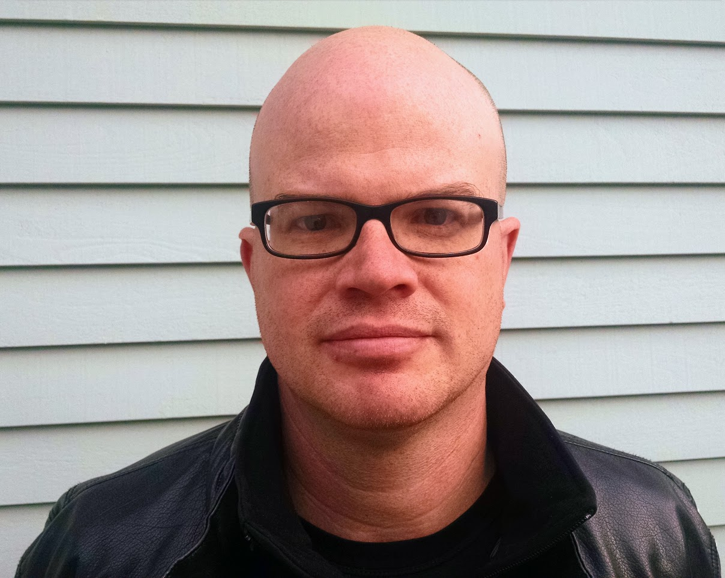*******../../../Assets/Logos/School%20of%20Business/1815/Style%201/RedlandsSB_Style1_white%20RGB%2072ppi.png

**Andrew Schroeder  
Andrew Schroeder, PhD is the Director of Research and Analysis for Direct Relief, one of the country’s leading humanitarian health non-profits. He is also the Co-Founder of WeRobotics, a non-profit organization which builds local capacity in robotics for social good throughout the Global South. For the past decade, he has been working at the intersection of humanitarian aid, global health and spatial technology. Andrew has engaged in disaster relief operations from Myanmar to Haiti, Liberia and New York City, and on global health projects from the Philippines to Ethiopia to California. His work has been featured in publications including The Lancet, The Atlantic, Fast Company and Crisis Response. In 2013, he was honored by Esri with the President’s Award for his contributions to geographic information systems for humanitarianism and global health.**

**Learn more about the Center for Business GIS**

**and Spatial Analysis**

[**www.redlands.edu/gisab**](http://www.redlands.edu/gisab)

**About the event**

Over the past decade the world has experienced a remarkable series of crises. Floods, storms, fires and earthquakes are striking a larger population than ever before, in global megacities, coastal clusters and remote rural areas alike.  Pandemic diseases from the Ebola and Zika viruses to persistent infections like HIV, malaria and tuberculosis threaten millions annually.  At the very same time, the tools to understand, collaborate and intervene in crisis events has continued to make more people than ever before more able than ever before to contribute their intelligence, skills and labor to solving critical global problems. Geographic information and other spatial technologies including drones, satellites and social automation systems are transforming not only how we can know the space of crisis but how we can act upon it in strikingly new ways. Andrew Schroeder will discuss the evolution of the engagement between humanitarian aid and spatial technologies across the space of global crisis over the past ten years through his work with Direct Relief and WeRobotics in order to help understand the future of our collective effort to build a more resilient and equitable global society.

**RSVP to Ms. Christine Mee at** [**gisab@redlands.edu**](mailto:gisab@redlands.edu)

**By October 10, 2017**

**Tuesday, October 17, 2017  
6:00 p.m. – 7:30 p.m.**

University of Redlands Main Campus   
Casa Loma Room  
Dinner served at 5:30 p.m.

University of Redlands Main Campus   
Hall of Letters Room 100  
Lunch served at 11:30 a.m.

**Humanitarian Aid and Spatial Technologies in Crisis**

**Andrew Schroeder, Director of Research and Analysis for Direct Relief**

Fall 2017 Speaker Series

**Center for Business GIS**and Spatial Analysis

**Cyrus Shahabi, Ph.D.**

**Cyrus Shahabi** is Professor of Computer Science and Electrical Engineering and the Director of the Information Laboratory (InfoLAB) at the Computer Science Department and also the Director of the NSF's Integrated Media Systems Center (IMSC) at the University of Southern California (USC). He is also the director of Informatics at USC Viterbi School of Engineering. He was the CTO and co-founder of a USC spin-off, Geosemble Technologies, which was acquired in July 2012. Since then, he founded another company, ClearPath (recently rebranded as TallyGo), focusing on predictive path-planning for car navigation systems. He received his B.S. in Computer Engineering from Sharif University of Technology in 1989 and then his M.S. and Ph.D. Degrees in Computer Science from the University of Southern California in May 1993 and August 1996, respectively. He authored two books and more than two hundred research papers in the areas of databases, GIS and multimedia with more than 12 US Patents.